1. Write a program to print ASCII values of all backslash characters and white space on screen in following format :

The ASCII value of ‘\t’ is : 9

#include<stdio.h>

#include<conio.h>

void main()

{

char a;

clrscr();

a='\a';

printf("\nthe ascii value of'\\a' is:%d",a);

a='\b';

printf("\nthe ascii value of '\\b' is:%d",a);

a='\f';

printf("\nthe ascii value of '\\f' is:%d",a);

a='\n';

printf("\nthe ascii value of '\\n' is:%d",a);

a='\r';

printf("\nthe ascii value of '\\r' is:%d",a);

a='\t';

printf("\nthe ascii value of '\\t' is:%d",a);

a='\v';

printf("\nthe ascii value of '\\v' is:%d",a);

a='\?';

printf("\nthe ascii value of '\\?' is:%d",a);

a='\\';

printf("\nthe ascii value of '\\\' is:%d",a);

getch();

}

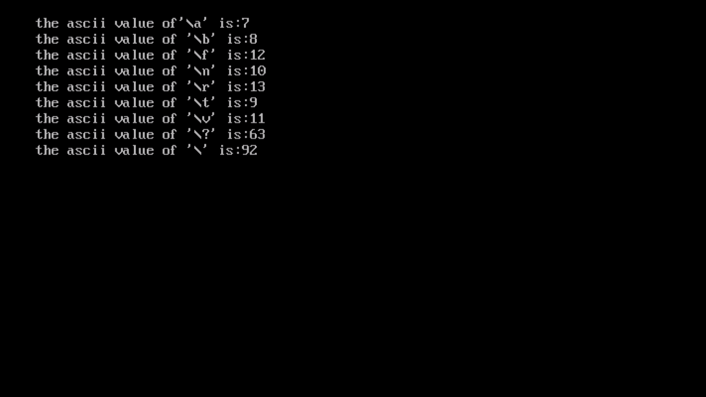

2. Explain different data types available in C.

Ans : There are main three data types.

1. Derived data types

* Array
* Function
* Pointer
* Reference

1. Built-in data types

* Integral type
* Int
* Char
* Floating type
* Float
* double
* Void

1. User-defined data types

* Structure
* Union
* Class
* Enumeration

3.Explain about C Tokens in brief.

Ans : C tokensare the basic buildings blocks in C language which are constructed together to write a C program.

Each and every smallest individual units in a C program are known as C tokens.

C tokens are of six types. They are,

* + - 1. Keywords
      2. Identifiers
      3. Constants
      4. Strings
      5. Special symbols
      6. Operators

1. Explain about backslash characters in C.

Ans :

|  |  |
| --- | --- |
| Constant | Meaning |
| A | Audible alert (bell) |
| B | Back space |
| F | Form feed |
| N | New line |
| R | Carriage return |
| T | Vertical tab |
| V | Single quote |
| ‘ | Double quote |
| ? | Question mark |
| \ | Backslash |
| \o | Null |